Screen shot3 on GitHub showing section

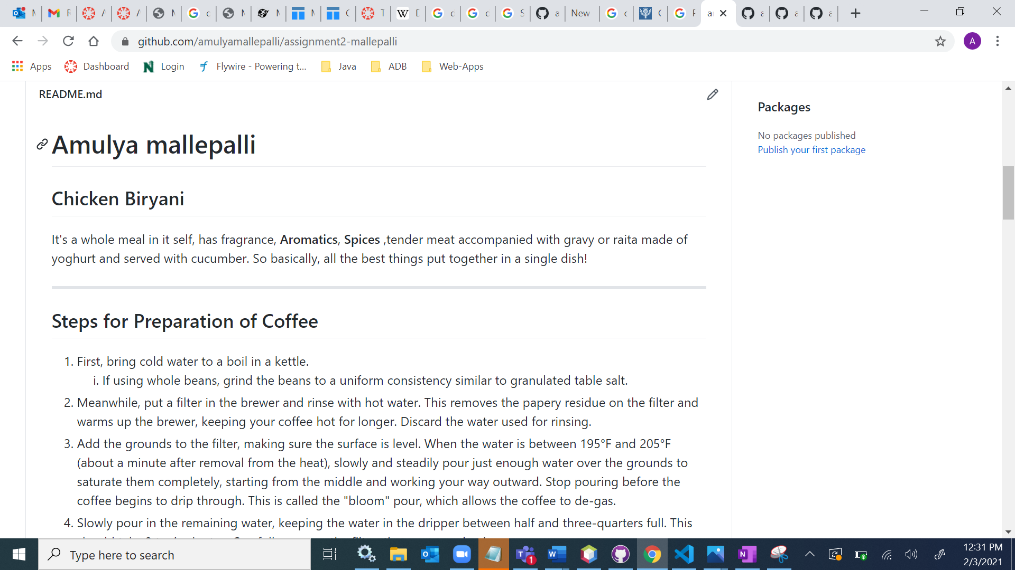

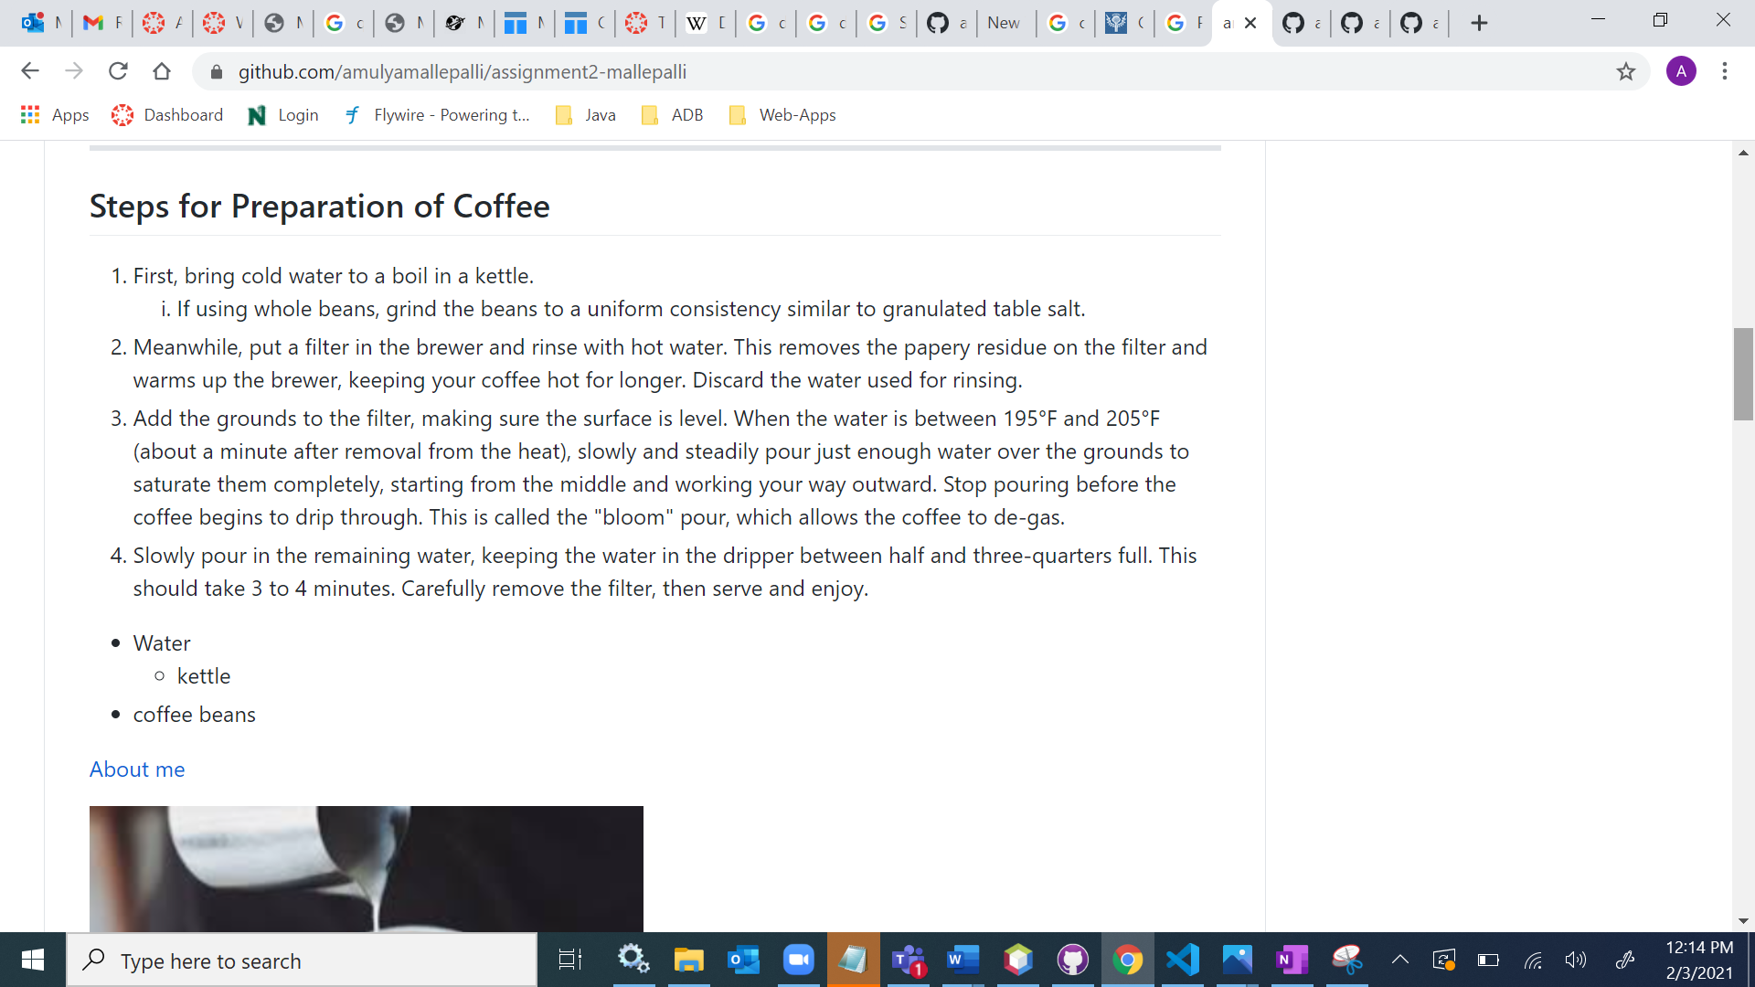

Screen shot 4 in GitHub desktop showing the state of the repo with the changes for README

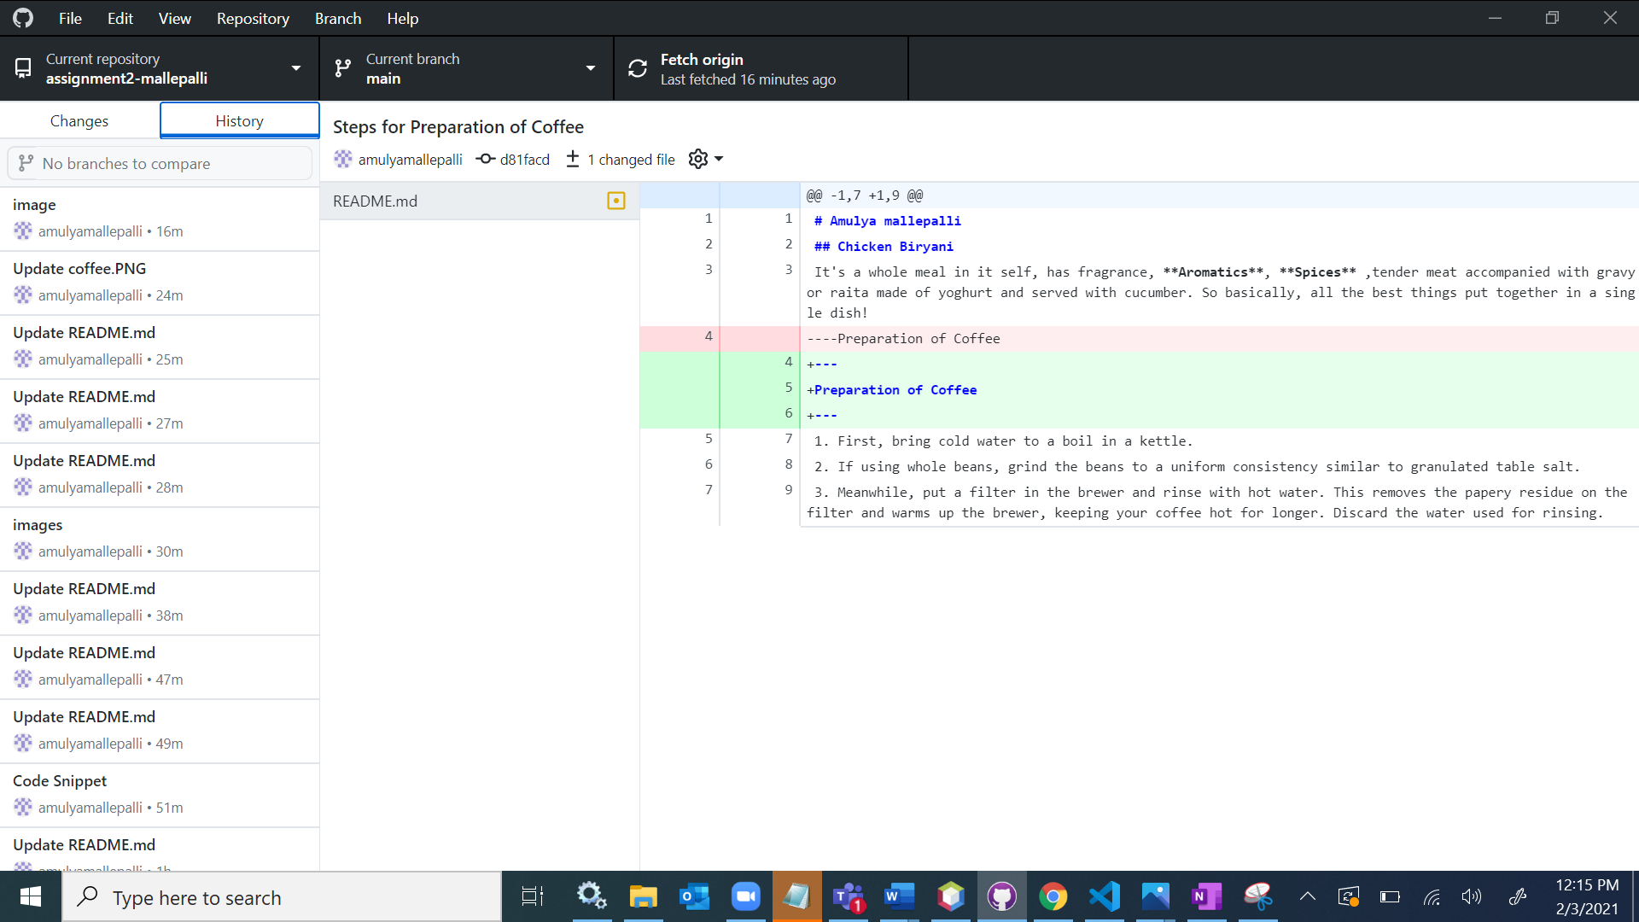

Screen shot 5 in GitHub desktop showing the changes for AboutMe

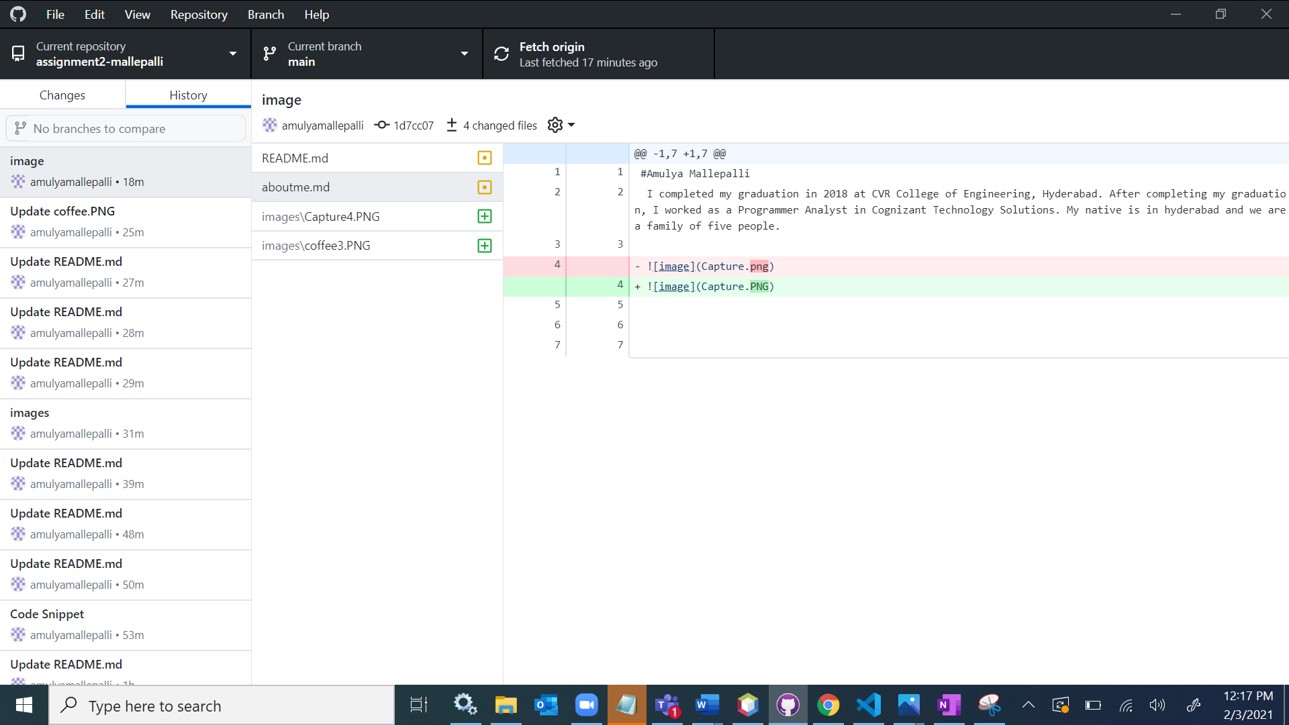

Screen shot 6 on GitHub showing the table section.

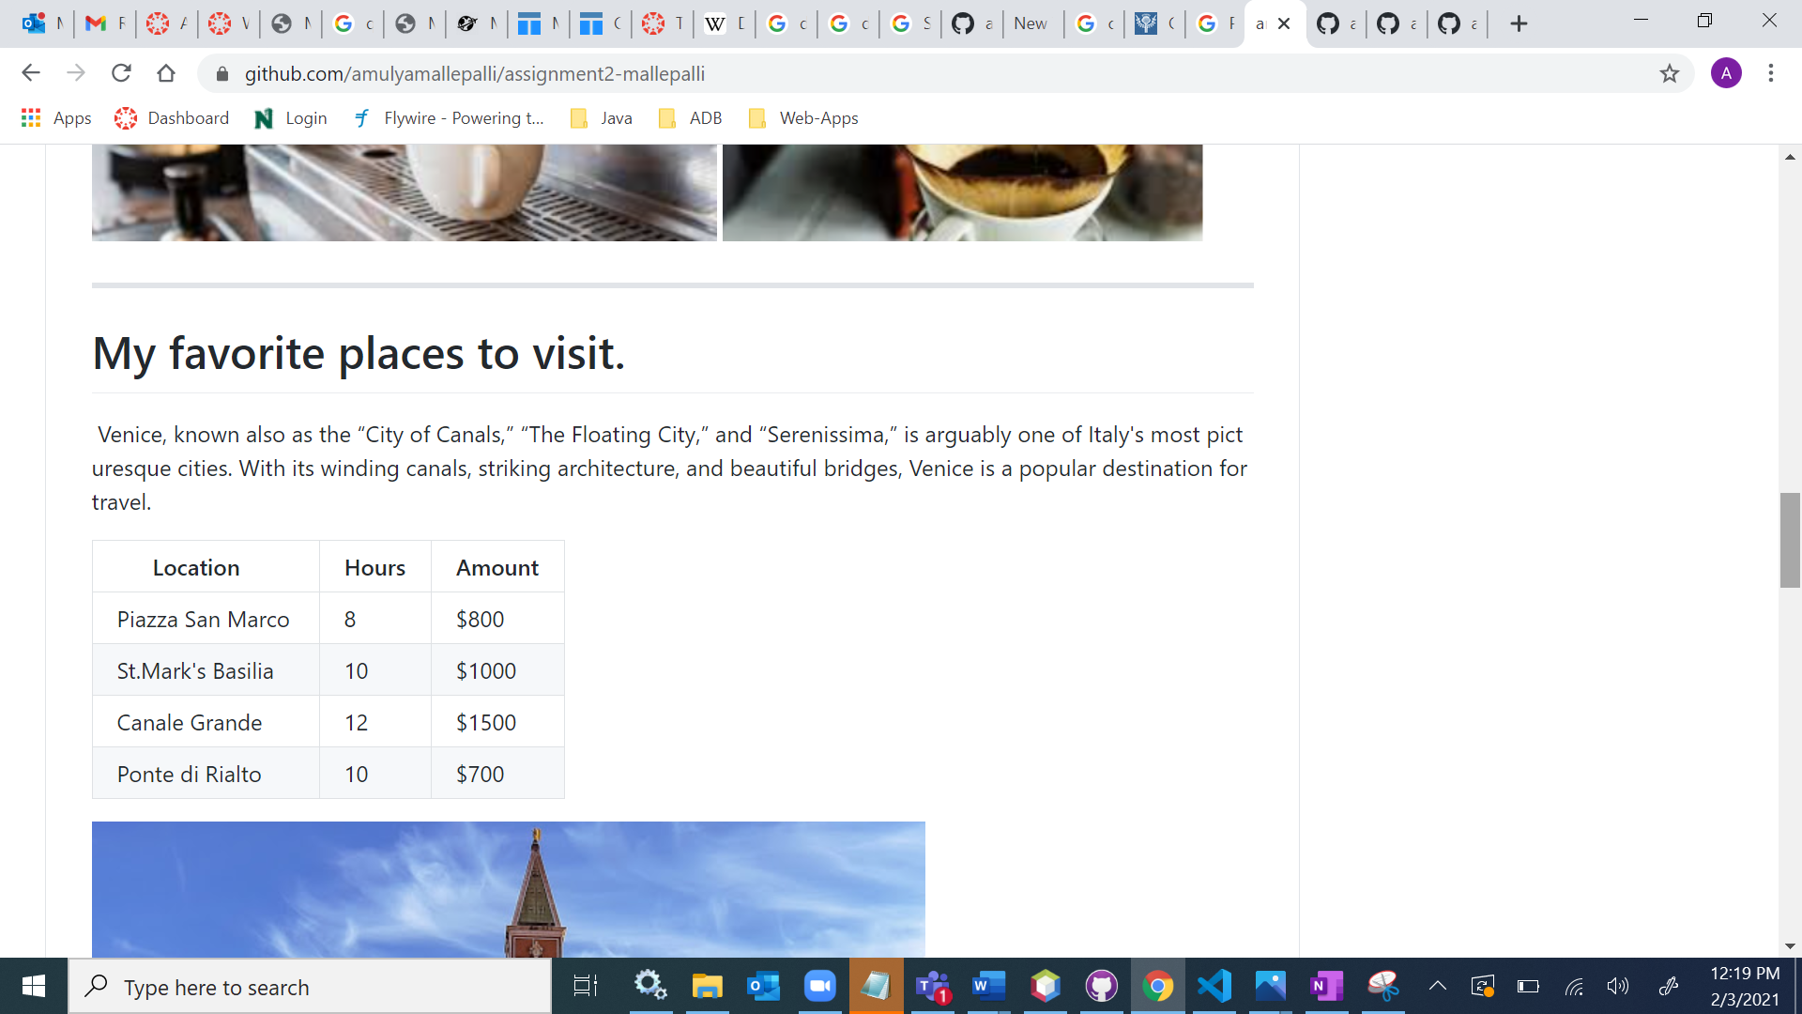

Screen shot 7 on GitHub showing the Quote section.

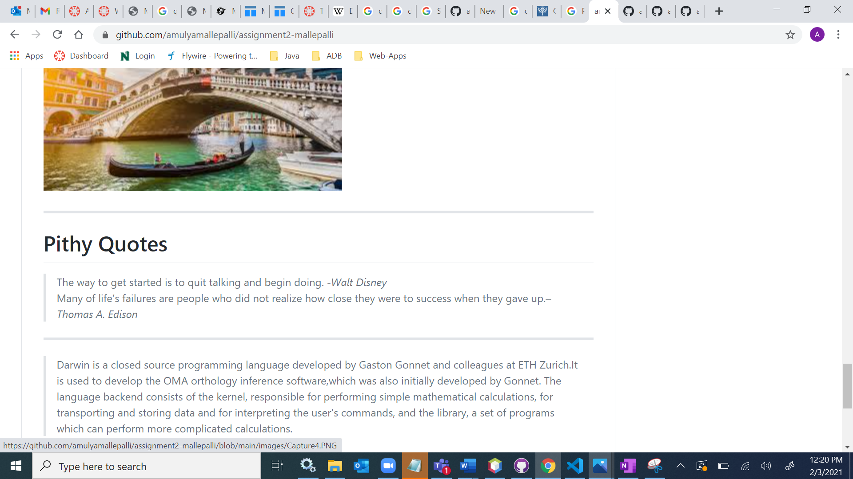

Screen shot 8 on GitHub showing the code fencing section.

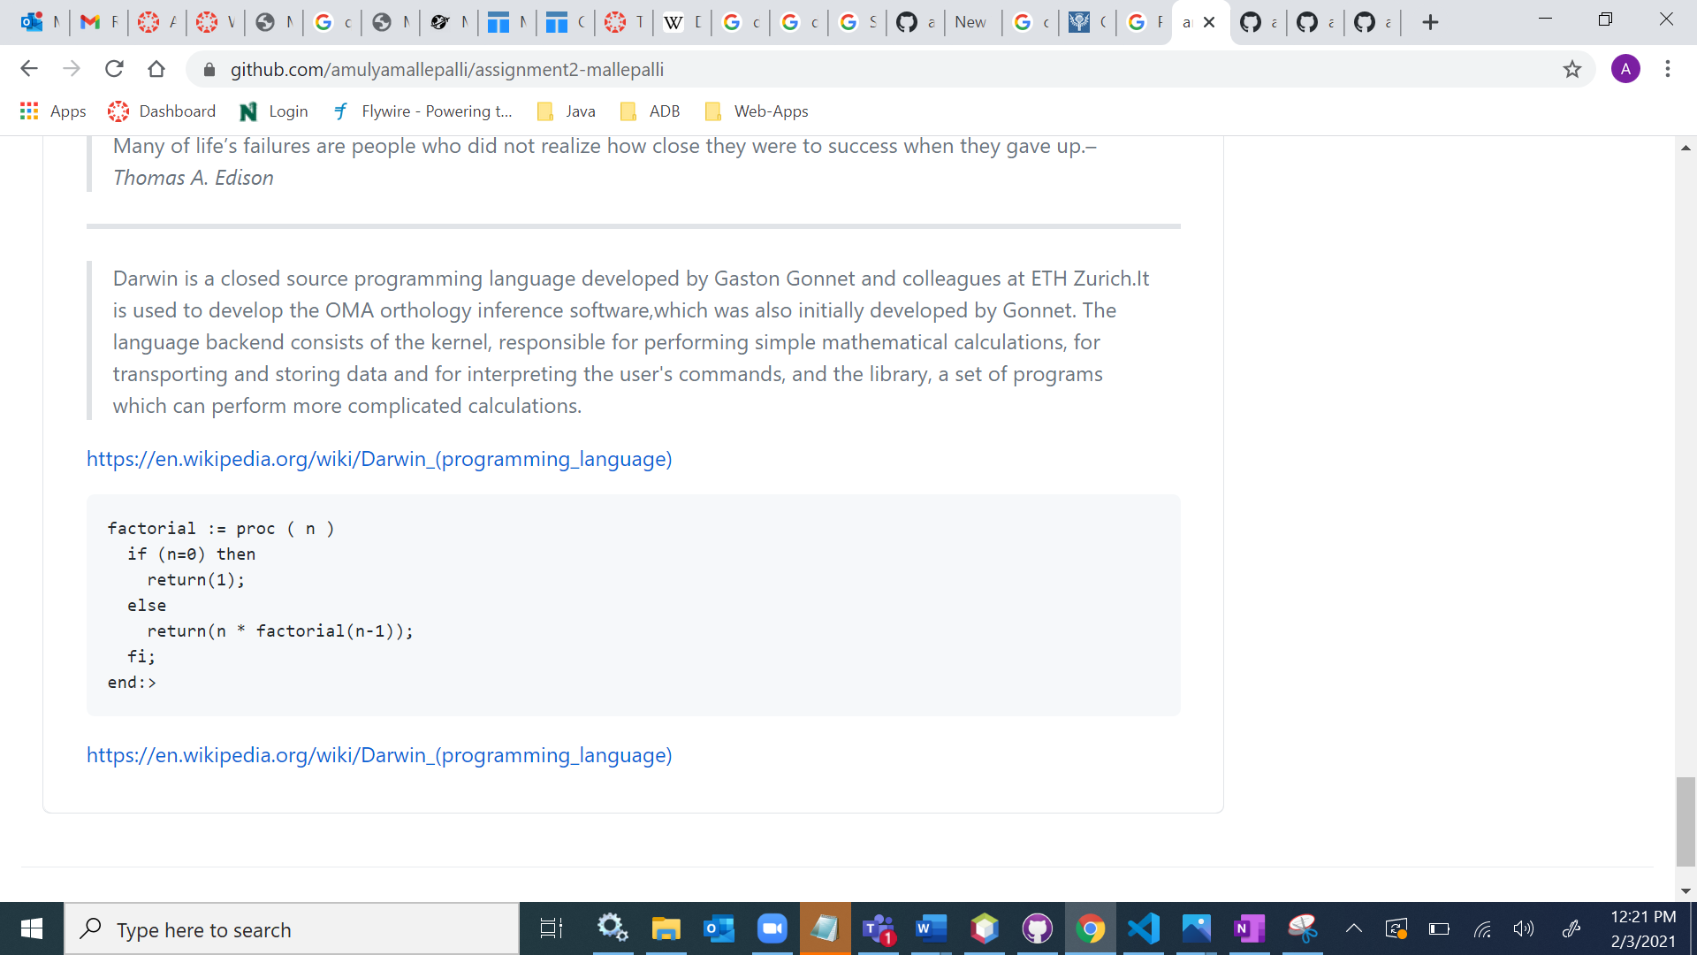

BONUS PART

